

Date Requested: 6/24/2010
Team Name: Team Homeless Titans Team Contact: Daniel Makin
Phone: 607-345-1638 Email: dpmakin@gmail.com
AP: Ron Powell

In the space below, please provide any necessary information regarding the asset requested (sprite size, color palette, animated behaviors, top-down or isometric orientation, etc.). ANY SKETCHES WILL BE HELPFUL! Your GAME DESIGN DOCUMENT must accompany your Asset Request Form.

Game Title: Captain’s Log

Brief Description of your game: Set in an ancient Greece of myth, the GAME places the player in command of a four man futuristic marine squad fighting for survival and to find a way back. The four man squad is comprised by the best of the best of the USMC, with all the technology available at the year 2152. This squad will face everything from small units, to minotaurs, harpies, chimeras and will even challenge the mighty god Zeus.

Description of request: A visual representation of the abilities and items to use for buttons and inventory. They should be a basic representation to match the theme of the interface, such as the basic unit controls.

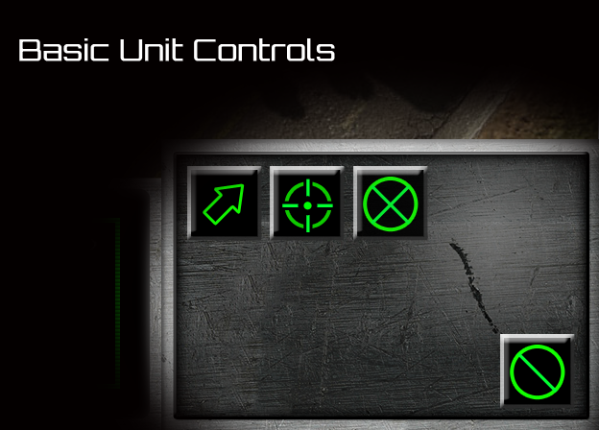

Abilities
Name | User | Type | Description; Visual Description
Heal Beam | ( Medic ) | Active ( Auto ) | Healing; outline of a gun with some sort of beam projectile coming out
Refresh | ( Medic ) | Active | 20 HP Heal; Plus sign with particles coming out
Defensive Matrix | ( Medic ) | Active | Makes unit invulnerable; wireframe sphere
Overdrive | ( Marine ) | Active | Attacking speed increase; gun with muzzle flare
Stun Grenade | ( Marine ) | Active | Stuns enemies in an area; exploding grenade
Commanding Presence | ( Marine ) | Passive | +5% HP when Marine is in range; General’s military insignia
Rocket Barrage | ( Heavy ) | Active | Fires 4 rockets over 2 seconds at target point; an arc of a rocket
Armor Lockdown | ( Heavy ) | Active | Speed decreases, takes 50% damage; shield
Flamethrower | ( Heavy ) | Active | Attacks in a line; flames
Cloak | ( Scout ) | Active ( Auto ) | Invisibility to units without detection, extra damage on first strike; outline of a person
Pinning Shot | ( Scout ) | Active | Targeted enemy stops / slows down depending on size; “electricity warning” lightening bolt aiming at legs of a person
Tactical Drone | ( Scout) | Active | Launches drone for scouting; mostly spherical aerial robotic drone

Items
Item Name | Type | Description; Visual Description
Book of Haste | Applied | Increases attack speed by 3%; Red angled book with red glow
Book of Swiftness | Applied | Increases movement speed by 3%; Yellow angled book with Yellow glow
Book of Protection | Applied | Increases Armor by 3%; white angled book with white glow
Book of Strength | Applied | Increases Attack damage by 3%; blue angled book with blue glow
Book of Vitality | Applied | Increases max HP by 5; green angled book with green glow
Gloves of Haste | Held (Passive) | Increases attack speed by 10%; red gloves
Boots of Swiftness | Held (Passive) | Increases movement speed by 10%; yellow boots
Shield of Angels | Held (Passive) | Increases Armor by 10%; white angel wings
Sword of Titans | Held (Passive) | Increases Attack damage by 10%; blue sword
Resurrection Stone | Held (Passive) | Brings back to life with 30% health (one time use); green tablet type stone
Gem of Life | Held (Passive) | Heals 1 HP / sec; green gemstone
Medusa's Torch | Held (Active) | Deals fire damage to enemy units in range, burn effect; a torch
Rod of Lightning | Held (Active) | Chain Lightning (5 targets); a lightening rod with lightening chaining to it
Tsunami Stone | Held (Active) | Tidal Wave (knockback + damage); wave
Ring of War | Held (Active) | Earthquake ( damage over time in area + slowdown); ring with red gem
Arc of Life | Held (Active) | Group Heal + heal over time; green glow
Wizard's Staff | Held (Active) | Teleport a short distance; a wizards staff
Stone of the Dead | Held (Auto) | Summons two skeletons; stone with skull on it

Please submit request to the server and notify your AP

Each team is limited to TWO Asset Requests per class month. Revisions and/or additions to completed or in-progress work WILL NOT BE HONORED. This form MUST be completed in full before any work can begin. Please allow AT LEAST 3-5 days for completion of your request.

92805

